AL-FARABI KAZAKH NATIONAL UNIVERSITY | 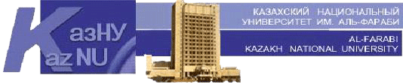

Faculty of philology

“Approved”
Dean of the faculty of
philology and world languages
__________ B.U. Dzholdasbekova

«_______»____________2021.

Methodical recommendations for the preparation of EMCD:
“Map of educational and methodological provision of the discipline”

Discipline’s title: Practical Grammar of the First Foreign Language
Course / specialty: 1, foreign language: two foreign languages
Semester: 2

№ | Textbooks | Internet resources | Quantity in the library | %  of provision
1. | New Headway Intermediate.– 3rd edition. Student’s book |  |  | 100%
2. | New Headway Intermediate – 3rd edition. Work book |  |  | 100%
3. |  | What a life  High beginning
4. |  | English Vocabulary  Intermediate wordlist

Considered and recommended at a meeting of the Department of General Linguistics and European Languages from “____” _____ 2021, minutes No. ___

Head Department _________________ R.A. Avakova

Approved by the Methodological Council of the Faculty of Philology
dated “___” _____ 2021 , minutes No. ___

Chairman _____________________ N.B. Sagyndyk

